


SOFTWARE DESIGN SPECIFICATION
Cyber Security
Web Service Open to Malicious Attacks

Created By: | Anish Akhilesh Gupta (IP-11783) | Approved By: | Harshada Topale
Created On: | 15-Sep-2026 | Approved On: | -

Page left blank intentionally

INDEX
1 PURPOSE 2
2 PROJECT SCOPE 2
3 SYSTEM OVERVIEW 2
4 DESIGN CONSIDERATIONS 2
4.1 Requirements 3
4.2 Assumptions 3
4.3 Dependencies 3
5 SYSTEM ARCHITECTURE 3
5.1 Architectural Strategies 4
5.2 Structure & Relationships 4
6 DETAILED DESCRIPTION OF COMPONENTS 4
7 INTEGRATION 5
8 APPENDICES 1
8.1 Appendix A – Detailed Description of Components 1

PURPOSE
This document is created based on the requirement specification document. The purpose of this Software Design Specification (SDS) Document is to break down the project into components to describe in detail what the purpose of each component is and how it will be implemented. The SDS will also serve as a tool for verification and validation of the final product.

PROJECT SCOPE
The scope of this project covers a complete security audit of giftacareer.in and a supporting steganography utility. The audit's distinct components allow identification of vulnerabilities across the network, server and application layers using Nmap, Nikto and OWASP ZAP, enabling the asset owner to understand and remediate its security posture.
Limitations: testing is unauthenticated (black-box) and limited to the authorised hosted instance only; no brute-force or DoS/DDoS testing was performed.

SYSTEM OVERVIEW
This section outlines the components and subsystems of the security-audit workflow and the steganography utility.
The workflow has four components: (1) Scope Control, which restricts all activity to the authorised hostname; (2) the Nmap Scanning component, covering network/service/TLS/header/vulnerability checks; (3) the Nikto Scanning component, covering web-server misconfigurations; and (4) the OWASP ZAP Scanning component, covering application-layer vulnerabilities. Each component writes its raw output to a dedicated log/report file, which are then consolidated into a single Findings Document. A separate, independent Steganography Utility component hides and recovers a text message inside an image.
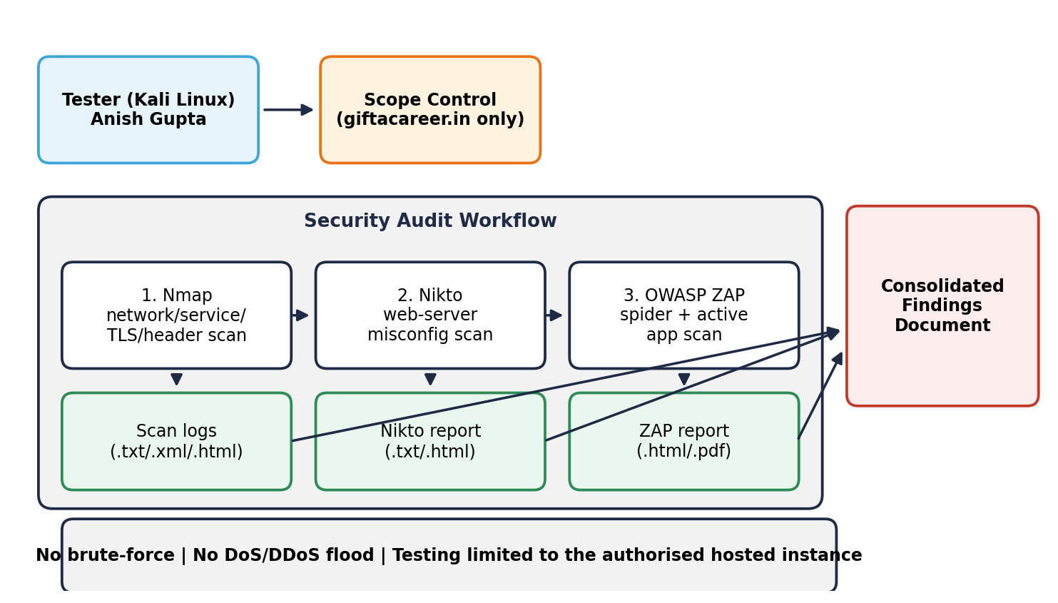

DESIGN CONSIDERATIONS
This section describes requirements, assumptions and dependencies to be addressed to devise a complete design solution.

Requirements
The functional requirements identified in the SRS are:
• FR-01/FR-02 Host discovery, port/service scan and OS fingerprinting.
• FR-02/FR-03 SSL/TLS certificate and cipher checks; HTTP security-header checks.
• FR-04 Known-CVE vulnerability scripts.
• FR-05 Directory/admin enumeration and backup/config exposure checks.
• FR-06 HTTP-methods check.
• FR-07 Full Nikto scan (HTTP and HTTPS).
• FR-08 OWASP ZAP spider and active scan, with exported report.
• FR-09 WAF detection.
• FR-10 Non-flooding DoS-readiness check.
• FR-11 Consolidated findings documentation with severity and patches.
• FR-12 Steganography encoder/decoder.
Non-functional requirements: safety (non-destructive testing), legality (scope strictly limited), repeatability (every command logged) and traceability (every finding linked to its evidence file).

Assumptions
• Formal authorisation exists to test the hosted instance of giftacareer.in, as stated in the Problem Statement.
• The Kali Linux environment with Nmap, Nikto and OWASP ZAP is sufficient; no additional paid tools are required.
• The provided hosted instance accurately represents the asset to be assessed.
• The external redirect target is outside authorised scope and is noted only, not tested.

Dependencies
• Kali Linux (or native installs) with Nmap 7.95, Nikto 2.5.0, OWASP ZAP.
• Python 3 with Pillow for the steganography utility.
• Stable internet connectivity to the authorised hosted instance.
• Guidance from the Project Manager on scope and deliverables.

SYSTEM ARCHITECTURE
The software system architecture refers to the logical organization of a distributed system into software components. It defines how components of a software system are assembled, their relationship and communication between them. It serves as a blueprint for software application and development basis for developer team. An effective architecture serves as the conceptual glue that holds every phase of the project together for all of its stakeholders, enabling agility, time and cost savings, and early identification of design risks.
The Software architecture:
- Defines structure of a system
- Defines behaviour of a system
- Defines component relationship
- Defines communication structure
- Balances stakeholder’s needs
- Influences team structure
- Focuses on significant elements
- Captures early design decisions

Below some important characteristics which are commonly considered are explained.
Operational Architecture Characteristics:
- Availability
- Performance
- Reliability
- Low fault tolerance
- Scalability

Structural Architecture Characteristics:
- Configurability
- Extensibility
- Supportability
- Portability
- Maintainability

Cross-Cutting Architecture Characteristics:
- Accessibility
- Security
- Usability
- Privacy
- Feasibility

Architectural Strategies
• Defence in depth evaluation: each layer (network, server, application) is checked independently so that a gap in one does not go unnoticed because another layer looks secure.
• Least-intrusion testing: every technique used is detection/verification-only; no destructive or flooding technique is used, per the Problem Statement's rules.
• Cross-verification: a finding is only reported with confidence when corroborated by more than one tool where possible (e.g. the missing-HSTS finding appears in both Nmap and Nikto output).
• Strict scope boundary: every command explicitly targets only the authorised hostname; the external redirect is documented but never scanned.
• Evidence-first reporting: every finding in the Findings Document links back to a specific raw output file.

Structure & Relationships
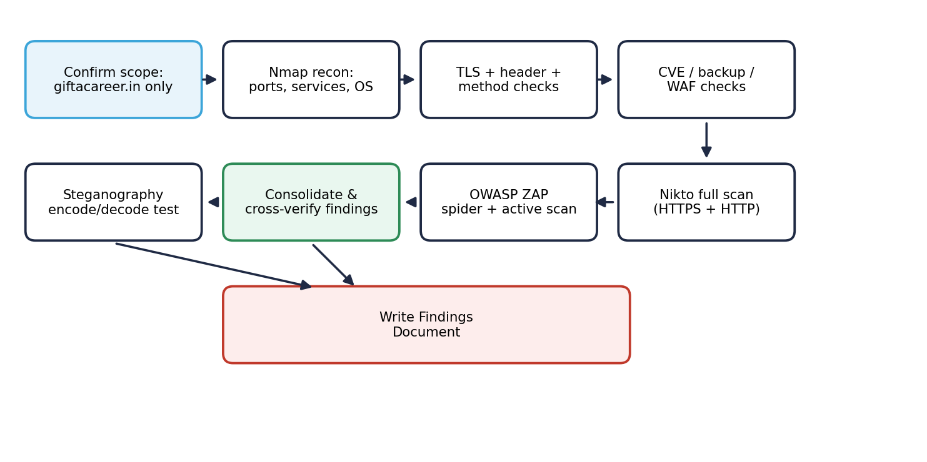

DETAILED DESCRIPTION OF COMPONENTS
For detailed description of the components, please refer Appendix A – Detailed Description of Components

The below template will be used to specify the details of all the components
Table 1: Detailed Design Specification Template
Identification | The unique name for the component and the location of the component in the system.
Type | A module, a subprogram, a form, a data file, a control procedure, a class, etc.
Purpose | Function and performance requirements implemented by the design component, including derived requirements. Derived requirements are not explicitly stated in the SRS - but are implied or adjunct to formally stated SDS requirements.
Subordinates | The internal structure of the component, the constituents of the component, and the functional requirements satisfied by each part.
Dependencies | How the component’s function and performance relate to other components. How this component is used by other components. The other components that use this component. Interaction details such as timing, interaction conditions (such as order of execution and data sharing), and responsibility for creation, duplication, use, storage, and elimination of components.
Interfaces | Detailed description of all external or internal interfaces as well as of any mechanism for communicating through messages, parameters, or common data areas. All error messages and error codes should be identified. All screen formats, interactive messages, and other user interface components (originally defined in the SRS) should be given here.
Resources | A complete description of all resources (hardware or software) external to the component but required to carry out its functions.
Processing | A full description of the functions presented in the Function subsection. Pseudocode can be used to document algorithms, equations, and logic.
Data | For the data internal to the component, describes the representation method, initial values, use, semantics, and format.

INTEGRATIONS
This project integrates with the following tools:
• Nmap 7.95: network, service, TLS, header and vulnerability-script scanning of the authorised target.
• Nikto 2.5.0: web-server misconfiguration scanning over HTTP and HTTPS.
• OWASP ZAP: application-layer spidering and active vulnerability scanning, with HTML/PDF report export.
• Python 3 + Pillow: implements the LSB steganography encoder/decoder.
• curl: used for manual spot-verification of specific HTTP headers.

APPENDICES

Appendix A – Detailed Description of Components

Identification | Scope Control (manual check before every scan)
Type | Procedural control, not code
Purpose | Ensures every scan command targets only the authorised hostname giftacareer.in and never the external redirect target.
Subordinates | N.A. (applies to all scanning components).
Dependencies | Precedes every other component; all scans depend on scope being confirmed first.
Interfaces | Input: the Problem Statement's authorised asset. Output: a confirmed target hostname used in every subsequent command.
Resources | The Problem Statement document itself.
Processing | 1) Read the authorised hostname from the Problem Statement. 2) Confirm it before every scan command. 3) If a redirect to another domain is observed, record it but do not scan it.
Data | Target hostname: giftacareer.in.

Identification | Nmap Scanning Component (CLI commands, output to /scans)
Type | Command-line tool invocations
Purpose | Performs host discovery, port/service/version detection, OS fingerprinting, SSL/TLS checks, HTTP security-header checks, HTTP-methods checks, known-CVE scripts, backup/config exposure checks and WAF detection.
Subordinates | Sub-scans: host discovery, port/service scan, SSL/TLS check, header check, vuln script scan, enum scan, methods check, WAF detection, DoS-readiness check.
Dependencies | Depends on network connectivity to the target; its output feeds the consolidated Findings Document.
Interfaces | CLI: nmap flags (-sV -sC -p- --script ...). Output: text/XML/gnmap log files saved under /scans.
Resources | Nmap 7.95 and its NSE script library.
Processing | 1) Run host discovery. 2) Run full port/service scan. 3) Run targeted NSE scripts for TLS, headers, methods, vulnerabilities, backups and WAF detection. 4) Save all raw output.
Data | Output: nmap_report.txt, nmap_full_report.xml/.gnmap/.nmap.

Identification | Nikto Scanning Component (CLI command, output to /scans)
Type | Command-line tool invocation
Purpose | Scans the web server for misconfigurations: outdated banners, missing headers, default/interesting files, directory indexing.
Subordinates | Two runs: full HTTPS scan and a port-80 HTTP scan.
Dependencies | Depends on network connectivity; its output is cross-verified against the Nmap header findings.
Interfaces | CLI: nikto -h <target> [-p 80 | -ssl]. Output: text and HTML report files.
Resources | Nikto 2.5.0.
Processing | 1) Run the full scan over HTTPS. 2) Run a scan over HTTP (port 80) to check redirect behaviour. 3) Save both raw outputs.
Data | Output: nikto_report.txt, nikto_full_report.html, nikto_live.txt.

Identification | OWASP ZAP Scanning Component (GUI, output exported)
Type | GUI-driven application scanner
Purpose | Crawls the site (spider) and actively tests every discovered page/parameter for SQL injection, XSS, insecure cookies and clickjacking.
Subordinates | Spider phase and Active Scan phase.
Dependencies | Depends on network connectivity; its Alerts are cross-verified against Nmap/Nikto header findings.
Interfaces | GUI: Automated Scan with target URL. Output: HTML/PDF report exported via Report > Generate Report.
Resources | OWASP ZAP (latest stable) and a browser.
Processing | 1) Enter the target URL. 2) Run the spider to map the site. 3) Run the active scan against every discovered page/parameter. 4) Review the Alerts tab and export the report.
Data | Output: a dated ZAP HTML/PDF report (e.g. 2026-10-15-ZAP-Report-.html).

Identification | Findings Consolidation (manual, into the Project/Findings Report)
Type | Documentation process
Purpose | Cross-verifies and consolidates findings from all three tools into one severity-ranked Findings Document with suggested patches.
Subordinates | Reads the outputs of the Nmap, Nikto and ZAP components.
Dependencies | Depends on all three scanning components having completed; feeds directly into the Project Report.
Interfaces | Input: raw log/report files. Output: the Findings Document (Project Report + appendices).
Resources | Manual review; Microsoft Office/LibreOffice for documentation.
Processing | 1) Read each tool's raw output. 2) Match related findings across tools (e.g. missing HSTS seen in both Nmap and Nikto). 3) Assign severity and a suggested patch. 4) Record each finding in the Traceability Matrix.
Data | Findings table: #, finding, tool, severity, suggested patch.

Identification | Steganography Utility (encode.py, decode.py)
Type | Python scripts
Purpose | Hides the text message "Cloud Counselage Internship Program" inside a PNG image using LSB encoding, and recovers it exactly via a matching decoder.
Subordinates | encode_message(), decode_message() functions.
Dependencies | Independent of the scanning components; uses the Pillow library only.
Interfaces | CLI: python encode.py <input.png> <output.png>; python decode.py <output.png>. Output: an encoded image and the printed recovered message.
Resources | Python 3, Pillow.
Processing | 1) Convert the message to bits with a termination delimiter. 2) Overwrite the least-significant bit of each pixel channel with the message bits. 3) Save the new image. 4) The decoder reads the LSBs in the same order, reconstructs the bytes, and stops at the delimiter.
Data | Input: cover image + message text. Output: encoded PNG + recovered message string.

